Requirements

Requirements
- System independence: It will be independent of other systems like triple stores and pipelines, ensuring it can operate as a standalone service
- Pluggable inference engine: The inference engine within the entity resolution service will be designed to be pluggable, allowing different teams to replace it with their preferred neural network or inference engine
- Adaptable: It should be "adaptable" to cover different kinds of entities with minimum configuration changes.
- User feedback support: It should allow for a collection of user feedback on resolved entities
- Remotely accessible, standalone service
- Open Source
- Secure access via EU login: user-facing web application needs to be accessed using the specific authentication mechanism, that is EU Login

Identified architecture characteristics
The provided requirements have been further expanded and translated into the following system characteristics:
- Independence: The system is independent of other systems like triple stores and pipelines, ensuring it can operate as a standalone service.
- Durability: Requests are written to disk and retained for a configurable period (infinite).
- Replayability: Consumers can read messages from any offset, even ones they already processed; a newly plugged engine can reprocess all data submitted by users (ER requests, link curation data).
- Modularity: The system is composed of decoupled modules that can function independently.
- Replaceability: ER engines can be easily substituted with alternatives without major changes.
- Interoperability: The ER service and an ER engine interact with each other through a well-defined API and the interaction adheres to an established contract. The same applies to the ER service itself.
- Independence: The system does not depend on any external systems.
- Adaptability: The system should be "adaptable" to cover different kinds of entities with minimum configuration changes.
- Usability: It supports recording user feedback.
- Transparency: The APIs (ERS and ER engine) should be understandable and well-documented.
- Maintainability: It should be easy for external contributors to understand and contribute to the project.
- Authentication: Identity of users accessing the web application should be verified.

Requirements matrix
The matrix presents system features and components associated with architectural characteristics that they fulfill.

Characteristic  \  feature/design aspect | Durability | Replayability | Modularity | Replaceability | Interoperability | Independence | Adaptability | Usability | Transparency | Maintainability | Authentication
ERE autonomy |  |  | X |  |  | X
ERE replaceability |  |  |  | X
Internal communication |  |  | X
middleware | X | X | X | X
log-based storage | X | X |  | X
API specification standards |  |  |  |  | X |  |  |  | X | X
Documentation |  |  |  |  | X |  |  |  | X | X
ER engine contract |  |  |  |  | X |  |  |  | X | X
TED pipeline integration |  |  | X |  |  | X
Entity data schema and model, Entity type specification |  |  |  |  |  |  | X
Internal identifiers |  |  |  |  |  |  | X
User feedback |  |  |  |  |  |  |  | X
Link Curation Web app |  |  |  |  |  |  |  | X
Link Curation API |  |  |  |  | X |  |  | X
ER engine |  |  | X |  | X | X |  |  |  | X
Authentication |  |  |  |  |  |  |  |  |  |  | X

Assumptions and limitations

Assumptions
Help streamline design decisions by relying on expected properties of system inputs.
- Each client (external system) guarantees the uniqueness of its request IDs.
- List of allowed origins (external systems sending requests to the ERS) is known in advance, defined in the ERS config that is processed during ERS startup.

Simplifications
Explicit decisions to reduce complexity or scope temporarily.

- The system will be tested against entities of a single type, that is organization (org:Organization).
- For the first project iteration, no data conversions are foreseen at the ERS level.
- The planned Jupyter notebook needs to present considered algorithms in action. For that, a minimal required flow should be implemented, there is no need to involve the ERS internals (Python and REST APIs).
- Support for (at least) a single input data format.
- No metadata maintenance. Only a minimal set of metadata (e.g. origin) required for operation will be processed.
- No centralized configuration management nor dynamic configuration supported. Configuration is specified in static files. A slight overlapping of the ERS and ERE config may occur, as the ERS won’t propagate shared config properties to the ERE.

Limitations
Weaknesses or inabilities of the system due to its design, technology stack, or decisions.

- No retraining of an ER model based on user feedback supported.
- No training of embeddings for entity data foreseen.
- No use of domain data model (ePO).
- No transformation of entity data is foreseen. The data is used by the ER engine as is.
- No use of a golden dataset.
- No integration with a master data registry (MDR).
- No support for authorization (RBAC).
- The System of Records does not support querying (e.g. fetching specific entity properties).
- ERS is not going to clean or fix incoming data.
- No interoperability is foreseen between implementations of ER engines. No standard is established for the internal representation of the canonical entities, and each ER engine implements its own logic based on the chosen technology and data model, provided that it respects the ER engine contract.

Constraints
Rules or limitations the system must work within when meeting those requirements.

- All input data from resolution requests must be preserved.
- No historical data will be removed. This applies to both input and output data generated by the resolution process. Legacy canonical entity data will be retained to support lookup requests for previously assigned canonical URIs.
- The ER algorithm must not require a predefined number of clusters. It shall discover them.

User journeys and workflows

Overview
The document describes workflows to be supported by the ER system (user journeys). The flows are described in a textual manner through a list of steps that are executed in the system.

The two most important user journeys described in this document are comprehensively represented on dynamic diagrams presenting system components, configuration and exemplary data:
- ER user journey for TED pipeline
- Link curation

Resolve an entity
Input:
- Entity object in one of the data formats supported by the ER system
Output:
- URI of the resolved entity
Side effects:
- Resolved entity for any new input entity stored in the ERE

- A user submits a request (represented by request object) through POST /resolve​ endpoint.
- the object is checked for completeness (see input object specification) and correctness (optional).
- The entity object and metadata are stored in the system of records.
- The entity resolution (ER) engine is fed with the entity.
- The ER algorithm is executed. As a result:
  - The RDR (ERE internal database(s)) is populated with:
    - updated clusters (correspondences of master URI & mention URIs)
    - updated canonical entities (materialized)
    - lineage information
- The resolved identifier (URI) is sent back to the user together with the confidence level.

Get resolved entity details by a request ID
- The user submits a request with details of a past request through GET /entities/{originId}/{requestId} endpoint, providing requestId and originId.
- Canonical entity details are looked up in the middleware, using requestId and originId. If they don't correspond to any known resolved entity then the user is notified about it.
- If the canonical URI is found, the system further queries the middleware to ensure that the cluster is not superseded by a newer one (see Evolution of resolved entities over time).
  - If it has been superseded and:
    - replaced by the newer one, then the newer entity details (URI / description) are returned and the user is informed about that fact.
    - Invalidated by the newer one, then the user is informed that it’s impossible to determine a new URI and details of related entities are provided.
- If the entity is up-to-date then the details are returned to the user.

ER user journey for TED pipeline
A dynamic diagram depicting the flow on the architecture components using exemplary data.
The pipeline execution service acts as the user. The pipeline component would be executed after the TED data is converted to RDF. The ERS is available as a REST service and its lifecycle is independent of the pipeline component.
Input:
- RDF data of a Notice with some nested objects
- ER component configuration, including entity specification, extraction strategy and target property name for resolved entities (defined in a static YAML config file)
- ERS and ERE configuration (defined in static YAML config files)
Output:
- RDF data of a Notice, with canonical URIs appended to the relevant entities (CETs) nested in the Notice object using the configured property (owl:sameAs by default)
Side effects:
- Resolved entity for any new input entity stored in the ERE

- User (pipeline component) submits an RDF document (Notice) corresponding to a “parent” object that contains entities of one or more types (CETs).
- The object is checked for correctness (optional).
- Entities of supported types (CETs) are extracted from the input object according to the Entities extraction strategy.
- The ERS /resolve​ endpoint is called with the set of extracted entities. URIs of resolved entities linked to input entities are returned.
- The “parent” object is enriched with the returned URIs according to the enrichment strategy.

Link curation (Human in the loop)
A dynamic diagram depicting the flow on the architecture components using exemplary data.
- The user opens the Link Curation Web app.
- The application fetches automatic alignments from the ERS and presents it to the user. Each presented record includes:
  - The links themselves together with a similarity score
  - representations of both entities (as it's impossible to figure out entity meaning based on its opaque URI)
  - (on demand) Information about other entities in a cluster (along with their representations) represented by the target entity
- The links are presented in a convenient way (e.g. interactive table) to the user. Each entry presents a pair of links, similarity score and preview of representations of both entities. An entry contains buttons to either reject or accept a link.
- The user goes through the links and accepts or rejects some or all proposed links. The user can use a built-in browser to search links by an entity (textual representation of an entity)
- Once the user submits the form, the information is sent to the ERS, which stores the user feedback.

Design and decisions
ERS system proposal

Document overview 4
System overview 4
Data 4
Data format 4
Entity data format 4
Request and response data format 5
Configuration files data format 5
Entity data schema and model 5
Entity content 6
Entity type specification 6
Internal data organisation 6
Scope of data & metadata 6
Conceptual model 7
Data stores 7
Middleware log-based storage 8
Resolved Data Repository (RDR) 8
Entity resolution outcome 8
Evolution of resolved entities over time 8
User feedback 9
Automatic and manual alignments 10
API specification standards 10
ERS REST API 10
Streaming platform internal API 11
Behaviour 11
ER engine (ERE) autonomy 11
ERE replaceability 11
Internal communication 12
Maintaining historical data 12
Internal identifiers 12
Configuration management 13
Collecting user feedback 13
Authentication 13
No access control 13
Project 13
Code organization 13
Documentation 14
Testing 14
ERS 14
General 15
Asynchronous communication 15
User-facing API 15
Resolve 15
Get resolved entity details by request details 16
Get resolved entity details by canonical entity IDs 17
Get unresolved entity details by internal entity ID 18
Get unresolved entity details by internal entity IDs 19
Link Curation API 19
Get automatic alignments 19
Set manual alignments 21
Middleware API 21
publishResolutionRequest 21
fetchResolvedUri 22
fetchAutomaticAlignments 22
publishManualAlignments 22
fetchAutomaticAlignments 22
lookupUnresolvedEntities 22
lookupCanonicalEntities 23
ERS configuration 23
Request handling 24
Lookup request handling 24
ERE 24
General 24
ER solution 24
Characteristic of the ER solution 24
Alternative entity clustering algorithms 25
Middleware 26
Overview 26
Tech stack 26
Event Streaming Platform 26
Advantages of Event Streaming Platform 27
Streaming platform topics 28
ER request objects 28
Canonical entities 29
Automatic alignments 29
Manual alignments 30
Log index 30
Reading and Writing 31
Key Conventions 31
Entry Creation 32
ER system internal APIs 32
ER engine contract 32
The contract 32
Data contract for ERE 33
Middleware API 33
resolveEntity 33
rebuild 33
ERE Configuration 34
ERE base configuration 34
Link Curation Web app 34
UI and features 34
TED pipeline integration 35
Integration of the ERS component in the pipeline 35
New ERS component for the TED pipeline 35
Entities extraction 35
Location of entity root 35
Entity extraction strategy 36
Enrichment strategy 37
ER component configuration 37
ER component core config 37
Entity spec config 38

Document overview
This document presents the design of the proposed solution for the Entity Resolution System. It covers several important aspects, outlines architectural decisions along with their justifications, and, together with the architecture diagrams, constitutes the high-level architecture of the project. The described topics are grouped either by top-level system components or by overarching categories in the case of cross-cutting concerns.

System overview

The ER System objectives are to resolve entities by providing a canonical identifier and retrieve resolved data as well as provide a user interface for recording user feedback on the resolved data. The system consists of:
- the Entity Resolution Service that handles user requests and coordinates the entity resolution process,
- the Entity Resolution Engine that is the actual component executing the resolution
- the middleware that decouples the two services, provides a communication channel and storage for system data, and
- the Link curation app that is a web application for recording user feedback on resolved data.
In addition, outside the ER system, there is the TED pipeline that is subject to updates in the context of this project. A new component will be implemented to integrate the ER System in the pipeline.
The proposal is accompanied by a set of architecture diagrams depicting the structure of the system and interactions between the major components. Static architecture diagrams provide a quick insight into the organization of major system components. Dynamic (behaviour) diagrams present the workflows for two major use cases and help to understand the way components communicate with each other.
Deployment diagram presents the organization of executable system artefacts and infrastructure diagram provides further details and an overview of the runtime environment.

Data

Data format

Entity data format
A format of the entity data can be considered for the three processing levels (layers):
- TED SWS integration: doesn’t belong to the ER system, but is a part of the overall notice processing workflow (see ER user journey for TED pipeline).
- ERS: the service itself handling user requests and coordinating the work.
- ERE: the pluggable engine responsible for resolving entities.

The TED SWS integration operates on RDF data as described here.

The ERS supports entity data in potentially any format, and the first edition of the project will operate on RDF data. The ERS is not data-format-dependent and as many format-specific operations are deferred to the ER engine as possible.

One possible way of processing input entity data is as plain text. However, as the entity data stored in the middleware (see Middleware log-based storage) is annotated with its MIME type, it is possible for future ERE implementations to leverage other approaches. Specifically, one can distinguish between syntax- or format-aware approaches (which parse and navigate text based on structural cues like HTML tags or punctuation), model-aware approaches (which interpret formats like XML or RDF according to their underlying data models, such as the DOM or graph structures), and domain-aware approaches (which incorporate domain-specific knowledge, such as ontologies). The latter would require providing proper model specifications.

In principle, each ERE is free to decide on processing of input data as well as internal representation of resolved data as long as it conforms to the contract.
The planned first ERE implementation processes input as plain text and therefore operates on any textual data format. In the current workflow, the engine will receive RDF data.

Note: entity data is not passed directly between the three layers, but is embedded in messages specified using Request and response data format and following a structure defined in a respective API (e.g. the internal ERS API).

Request and response data format
The format of requests and responses passed in the system is fixed.
JSON is the format of choice for representing messages in both user-facing and internal communication because of its ubiquity, simplicity, and ease of use (human-readable format)

JSON is also the format of choice for representing messages in internal communication (see ER service - ER engine contract).

Configuration files data format
We will follow the recommendation described in the system vision and use YAML, primarily for user-facing configuration, whenever it is possible and reasonable (e.g., when there is no existing, adequate configuration management for a reused tool).

Entity data schema and model
The ER System primary use case is to support transformation of TED data that is already quite well described at the point it integrates with the ERS (ePO model). However, the ERS is not using a data model, domain model, nor data schema at the moment. Nonetheless, the system design does not restrict extensions for future data model support.

Entity content
Input to the ERS is expected to be structured data (described in one of the supported formats) that describes some aspects of the same entity. It is also called an unresolved entity. A request containing the entity data must specify an entity type (CET) as the entity is going to be evaluated in the context of such. If the input contains multiple entities of different types, only the target entity is resolved, while the others provide contextual information.

Entity type specification
Entity type specification is information about an entity class.
All Critical Entity Types (CETs), that is types to be supported by the ERS, need to be explicitly defined in the ERS configuration (and further passed to ERE).

Although not required, it is highly recommended to use URIs as identifiers of CETs. The aim is to use a universally known ID, which would be important when considering a broader datasets landscape.

Internal data organisation

Scope of data & metadata
The ERS system manages the following data that relates to the entity resolution task:
- Unresolved entities: input data provided for resolution by a user
- Lookup requests: requests for details of entities that have been already resolved, submitted by a user
- Clusters and canonical (resolved) entities: entity resolution outcome
- Alignments: Correspondences between unresolved and resolved entities
  - Automatic links: created by the ERE, can be inspected and assessed by a user
  - Manual links: a user decisions on automatic links
- Provenance metadata: metadata describing origin of processed data
- Cluster lineage metadata: metadata linking obsolete clusters to their successors, reflecting evolution of clusters over time
The ones in bold need to be persisted in the system.
The ones in italic need to be managed by every ER engine. The non-italic ones are handled by the ER service and middleware.
Alignments need to be supported by both ERE and ERS.

Conceptual model
A conceptual model depicting the core concepts and how they relate to one another:
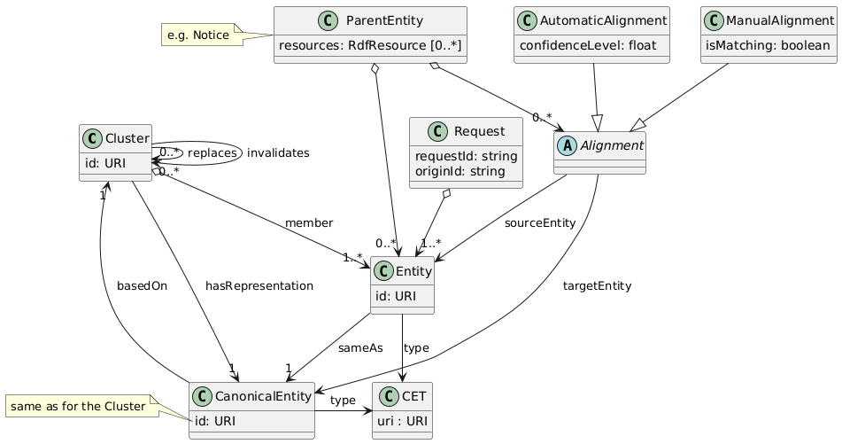
The model purpose is merely to depict the idea and guide the implementation.
Notes:
- ParentEntity relates to the bigger picture; it belongs to the execution context of the pipeline ERS component.
- Only positive (matching) alignments are materialized in the ParentEntity.
- Lineage metadata is captured through the use of replaces and invalidates properties.

Data stores
- Resolved Data Repository (RDR): ER engine operational store(s) (a single database or set of databases).
- Middleware log-based storage

Middleware log-based storage
The Streaming platform comes with a log-based storage that is used to store the ER system data. The store is a part of the middleware and it can be accessed by both the ERS and the ERE. Each log is related to a topic that has a specific purpose and a fixed message format.
The topics and their logs are described in the Streaming platform topic specification. The storage is immutable and retention policy can be adjusted if needed.

Resolved Data Repository (RDR)
RDR is a collective name for an ER engine internal store(s) used to store resolved data and information required for the engine to operate. The RDR is dedicated to an ER engine and tech stack chosen by an engine implementer fits the way the engine resolves entities. This is due to the fact that each ER engine may work with a different data format, and the structure of resolved data may vary as it reflects the business logic of the engine. See more in the Data contract for ERE.
Specification of RDR for the ERE implementation is described here.

Entity resolution outcome
ER engine resolves entities whenever possible. The resolution decision is based on a similarity threshold (also known as confidence threshold). During a resolution process, a similarity between an input entity and canonical entities (related clusters) is considered and the one with the highest similarity score that is equal to or greater than the threshold is selected as the canonical entity for the given one. That constitutes establishing a new automatic alignment between source entity (unresolved) and a canonical entity. The alignment can be perceived as linkage of a mention to its representative entity. If no canonical entities are found, then the input entity is treated as a distinct one and gets a new identifier.
A group of alignments referring to the same target entity is called a cluster. Note that the name doesn’t necessarily imply use of a clustering algorithm. A cluster collects unresolved entities that were considered similar and serves as the basis for the related canonical entity that is a materialized representation of all of them.

Evolution of resolved entities over time
As new data comes to the system, clusters evolve and entities formerly considered as a part of the same cluster can be split. Such a change affects related canonical entities. Whenever this happens, new clusters and canonical entities are defined (with new identifiers) and the former identifiers are linked to the new ones. This is stored as a part of lineage metadata and is used to track how a cluster evolved. Legacy canonical entity data will be retained to support lookup requests for previously assigned canonical URIs.
In other words, the system will generate new versions of resources and link previous versions to them, rather than modifying the same resources in place. Note that a resource and its predecessor are formally considered distinct, as they have different URIs. This approach is motivated by the assumption that any identifier produced by the ERS system may be used and referenced by external systems; therefore, modifying or deleting a resource description is considered unacceptable.

Lineage metadata
Note that the lineage metadata is created only if an ER engine supports them by tracking cluster progression. Otherwise, no lineage metadata is recorded.

Lineage metadata is appended to a canonical entity object and contains references to existing entities that are superseded by a new entity. The metadata object includes such keys as:
- replaces: a list of canonical URIs of entities that are superseded by the new entity.
- invalidates: a list of canonical URIs of entities that are no longer valid because of the new entity.
A difference between replaces and invalidates is that in case of the former, this entity can be considered as an evolution of anyone mentioned in the list and therefore safely used in place of the older entities. In contrast, invalidates is used when a new entity is a direct cause of another entity's deprecation, but it cannot be used in place of the former.
In practice, replaces should be used to annotate affected entities when two clusters are merged and invalidates when a cluster is split into two or more clusters.

Note that if clusters evolve through re-clustering then no lineage metadata is stored. Nonetheless, new manual alignments are established for all input entities collected so far that have been re-processed. In consequence, lookup requests return the new canonical URIs. All former canonical URIs are marked as deprecated.

Dealing with invalidated or deprecated URIs
Note that once an old canonical URI is marked as invalidated, it’s not usable anymore and no other can be provided in place of it. As the URI was once used for representing a set of unresolved entities submitted by the user, a need to obtain a new canonical URI for them arises. The user can submit new entity resolution requests for all affected unresolved entities to get up to date canonical URIs.

User feedback
A decision taken by the ER algorithm in an automatic way can be overridden by a user feedback. Even though it’s not in the scope of the current project, the idea is to adjust the ER engine state to honour user’s feedback. The process is also called link curation.
User feedback is understood as follows:
- Automatic alignments that have been already incorporated (into the RDF, that is ER database of resolved entities and clusters) are the subject for curation.
- A yes/no decision on an automatic alignment: The user can confirm or reject an alignment if it is considered incorrect.
- The user cannot provide their own alignments.

User feedback on an alignment is called manual alignment. It is similar to automatic alignment, but unlike automatic alignment, it can encode either positive (same as) or negative (different from) relation between two entities.

The user feedback is stored in the middleware, from where it can be retrieved by the ERE in the future.

Future considerations (out of the scope):
- Both rejection or acceptance of an alignment are recorded by the system, but only rejection would cause an impact on RDR.
- A user decision should be taken into account in two ways:
  - Affected clusters and canonical entities would be changed not to contradict with the decision.
  - When resolving an entity having the same description as one already evaluated by the user, the automatic resolution should be guided by the manual decision.

Automatic and manual alignments
The below table summarizes differences between the two types of alignments.

automatic alignment | manual alignment
Created by an ER engine | Created by a user
Standalone link | Based on and referring to an automatic alignment
Encodes same as relation between two entities | Encodes positive (same as) or negative (different from) relation
Maintained by an ERE (stored in RDR) | Maintained by the ERS
Stored in the middleware store.

API specification standards

ERS REST API
The user-facing ERS REST API will be specified using Swagger.

Streaming platform internal API
The async API of the Event Streaming platform will be specified using AsyncAPI standard (OpenAPI & Swagger equivalent for async APIs). This will ensure well-defined and unambiguous specification of the API along with documentation.
AsyncAPI seems to be the leading solution in the segment (It has 4.6k stars on GitHub and has been around for 6 years). Exposing the service specification described in the well-known standard would contribute to interoperability.
Moreover, a tooling around the standard exists, so additional utilities could be used (like code generation).

The API spec will specify:
- What messages are sent or received, and their structure (like JSON schemas).
- Who sends and who receives those messages (producers and consumers).
- The channels (like topics, queues, or routes) messages travel through.
- What protocol is used (like Kafka, MQTT, etc.).
- Message formats (e.g., what fields are required in an event).
- Bindings, which are protocol-specific settings (e.g., Kafka topic configuration).
- Security schemes, e.g., API keys or OAuth.
- Documentation elements like descriptions, tags, and examples.

AsyncAPI alternatives:
- Confluent Schema Registry

Behaviour

ER engine (ERE) autonomy
The ER engine operates independently of the ERS service as a distinct service. Similarly, it doesn’t rely on any external systems. It encapsulates the entity resolution logic and internally manages all required storage components. The ERE database(s) are not exposed outside and the ERS makes no assumptions about used technology.

ERE replaceability
Many ERE can be implemented and used with the ERS. The ERS and ERE don’t communicate directly, the work is facilitated by the event streaming platform instead. The ERS operates according to the well-defined ERS-ERE contract that brings in an interface for that purpose. The interface is language-agnostic (e.g. no-language-specific serialization). Any ERE implementation is expected to conform with that contract, that specifies communication channels, format of messages, roles and responsibilities of an ERE. Other than that, the ERS doesn’t introduce any behaviour specific to a particular ERE implementation.

Internal communication
The ERS and the ERE services are detached from each other and don’t communicate directly but rather through an event streaming platform that is a part of the middleware. The ERS produces (pushes to topics) the work (ER requests, lookups) to be done by an ERE. ERE polls “input” topics for new requests and pushes results to its “output” topics that are monitored by ERS and act on them as they arrive.
More technical details can be found in ER system internal APIs.

Maintaining historical data
Resources of some types that are stored in the log storage are going to evolve over time. It specifically affects resources generated by the system such as descriptions of canonical entities and organization of clusters. The data management strategy is to evolve new resources from existing ones and link to the formers instead of modifying them in place, as described in the Evolution of resolved entities over time. Note that the log-based storage model aligns well with the nature of data changes. The system leverages this by allowing lookup requests to be processed at the ERS and the middleware levels, without involving the ERE. In most cases, there is no additional cost to store ERE responses, as the data is already being pushed to a topic and can be retrieved by the ERS.
That said, if there is a need to remove obsolete data, each log (associated with a topic) can have a specified retention policy. Redpanda supports several types of retention policies, including Log compaction, which removes older versions of objects identified by their IDs.

Internal identifiers
In communication with a user (when handling user requests), the ERS rely on requestId, originId pair that is guaranteed to be unique. Apart from that, internally, the ERS generates local, unique identifiers (URIs) that are used throughout the ER system. This approach ensures uniform identifier management across all data and prevents potential conflicts that could occur if the service depended on user-provided entity identifiers.

Internal identifiers are generated for the following data:
- Input entities
- Generated canonical entities
- Generated clusters

The local URIs are generated before an entity is stored in the System of records. Therefore, all ER system components will rely on the same identifiers, especially an ERE and the Link Curation app. This is particularly important in order to enable lookup functionality for unresolved entities. Similarly, reprocessing entities with different ER engines will result in utilization of the same identifiers.

Configuration management
Both ER service and ER engine are configurable. The method of configuring the services is through static files that are processed during a service startup.
List of specification of ER system component configurations:
- ERS configuration
- ERE configuration
- Configuration of the TED pipeline integration component
The above list includes the TED integration component even though it’s not formally a part of the ER system.

Exemplary config files are presented in dynamic diagram presenting resolution of notice document entities in TED SWS pipeline.

Collecting user feedback
An ER engine won’t accommodate user feedback in this iteration of the project. Nonetheless, the user decision will be recorded so it could be used in the future to retrain/adjust an ERE. Read more in the User feedback.

Authentication
As the service will be publicly available on the Internet, an authentication method will be provided. The EU Login will be integrated into the ERS (user-facing interfaces).

No access control
The first version of the system won’t implement any role based access control (user management). It’s due to the time constraint and the questionable benefit of introducing it at this point.
Justification: A user is not significant to the system and we're not going to differentiate behavior (e.g. different curation credibility per user) or data access (restrict access to specific data) based on the user.

Project
Project-specific matters.

Code organization
Two new code repositories are foreseen for hosting the ER system codebase:
- er-system: for the core part of the ER system — that is, the ERS, the Link curation app and the middleware
- er-engine: for the ER engine
In addition, the OP-TED/ted-rdf-conversion-pipeline repository will include the new ERS component. In addition, the pipeline will be adjusted if needed.

Documentation
The following types of documentation will be prepared:
- User guide for the Link curation web application
- ER system general documentation: general explanation of the ER system, features and components
- ERS installation instruction
- ERE installation instruction
- ERS REST API reference (Swagger, see API specification standards): formal, technical specification of the API
- Middleware API reference (AsyncAPI, see API specification standards): formal, technical specification of middleware API
- ERE contract: specifies roles, responsibilities and connection points for a new ER engine to be implemented as well as rules to be followed
- ERE developer guide: provides practical information on how to implement own ER engine adhering to the ERE contract

Testing
Various types of automated tests will be implemented across different system levels, each serving a distinct purpose and offering unique insights:
- Unit tests: Focused on low-level validation of individual code components to ensure correctness in isolation.
- Feature Acceptance Tests (FATs): Applied at the component level, these tests are derived from feature specifications and written in high-level domain language (Given/When/Then), making them accessible to a broad range of stakeholders. They are particularly valuable for validating the acceptance of deliveries, each representing incremental progress in ER system components.
- End-to-End (E2E) tests: Validate complete workflows that align with system use cases. Like FATs, they use high-level domain language to ensure clarity and traceability across stakeholder groups

ERS
Matters specifically related to the ER service.

General
- ER service responsibilities:
  - Interacts with the user and handles their requests.
  - Serves the backend for Link Curation Web app and manages manual alignments
  - Acts as an intermediary between the user (the link curation UI / REST API) and the ERE; communicates with the ERE through the middleware
- ER service will expose the following APIs:
  - End-user-facing API
  - Internal Link curation API
  - Internal Middleware API
  - It also adheres to the ERE contract (see ERS API)

Asynchronous communication
The user-facing ERS API will be asynchronous. Performance of the ER process is not the primary concern at this stage and thus requests taking more than a few seconds could happen. Asynchronous communication won’t block the requester that would get a job ID as the immediate response. The job ID would let them poll the ERS for a result once it is available.

User-facing API
An API for the end user, providing methods to interact with the ER system. It’s an asynchronous REST API.

Resolve
POST /resolve
The main method used to submit an entity for entity resolution. A canonical URI is returned in response.

Request message
Type: object
Object description:

property | type | description | mandatory
entity | textual data | A representation of the entity | yes
entityTypeUri | string | A valid entity type URI as defined in the CET spec config | yes
entityDataFormat | string; MIME type | A data format of the entity data (passed as a request payload). | yes
requestId | string | Metadata describing an identifier of the passed entity used by the caller system. | yes
originId | string | Metadata describing originator (external system) of the request. | yes

Response message
Type: object
Object description:

property | type | description
canonicalEntityUri | string | The URI assigned by the ERS to the cluster where the entity is located.
sourceEntityUri | string | A generated internal id assigned to the input entity that was submitted for the resolution. The id was created as defined in the Identifiers of input entity objects. The URI can be used in the future to fetch resolution information for this entity.
confidenceLevel | float;  0 < confidenceLevel <= 1 | Indicator of the confidence in the cluster selection. It indicates the degree of certainty in the alignment between the submitted and canonical entities

Note: A batch version of this method could be implemented as well. In such a case, both request and response would contain arrays of objects described above. The user could use returned sourceEntityUri included in each response object to further fetch more information about the source object.

Get resolved entity details by request details
GET /entities/{originId}/{requestId}
The method for obtaining canonical entity description (canonical entity object, canonical URI) and auxiliary data by a request details. This method presumes that a particular entity has been already submitted and resolved by the system. Given a request ID, origin ID pair, it allows the requester to get a representation of the canonical entity that was generated and associated with the submitted unresolved entity. It returns details of the canonical entity that was established for the submitted entity.

Note that a cluster and its associated canonical entity might have been changed in the meantime. This method ensures the retrieval of the most recent resolution information for the entity identified by the request ID whenever possible.

Note that the endpoint can be extended to support internal entity ID (as described in Identifiers of input entity objects). This way, it would be possible to support multiple entities in the resolution request body and response.

Request message
Type: object
Object description:

property | type | description | mandatory
requestId | string | Identifier of a past request. | yes
originId | string | Identifier of an origin related to the past request. | yes
includeClusterMembers | boolean | If enabled, cluster entities are returned in addition to the canonical entity. Defaults to false. | no

Response message
Type: object
Object properties:

property | type | description
canonicalUri | string | An URI of the resolved entity.
canonicalEntity | textual data | A representation of the canonical entity in its original serialization format..
confidenceLevel | float;  0 < confidenceLevel <= 1 | Indicator of the confidence in the cluster selection.
clusterEntities | List[object] | A representation of entities that were used to form the cluster and canonical entity, specified in a serialization format defined by entityDataFormat.

Get resolved entity details by canonical entity IDs
Single resource version: GET /entities/{canonicalEntityId}?includeClusterMembers=false
Multiple resources version: POST /entities/batch

The method for obtaining descriptions of one or many canonical entities and auxiliary data based on a canonical entity ID. This method presumes the existence of a particular canonical entity and allows the requester to get representation of that entity. It also allows retrieval of descriptions for cluster entities, which are unresolved entities that contributed to forming the canonical entity representation.

Request message
Type: object
Object description:

property | type | description | mandatory
canonicalEntityIds | List[string] | List of entity identifiers which description should be returned. | yes
includeClusterMembers | boolean | If enabled, cluster entities are returned in addition to the canonical entity. Defaults to false. | no

Response message
Type: array of objects
Object properties:

property | type | description
canonicalEntityId | string | A full identifier of the canonical entity.
canonicalEntity | textual data | A canonical representation of the entity in a serialization format used by the cluster members.
clusterEntities | Optional[List[object]] | A representation of entities that were used to form the cluster and canonical entity, specified in their original serialization format.

Get unresolved entity details by internal entity ID
GET /unresolvedEntities/{entityId}

The method for obtaining canonical entity description (canonical entity object) and auxiliary data based on an internal entity ID. This method presumes the existence of a particular entity already submitted by a user for resolution and allows the requester to get representation of it.

Get unresolved entity details by internal entity IDs
POST /unresolvedEntities/batch

A method for obtaining descriptions of unresolved entities and auxiliary data based on an internal entity IDs. This method presumes the existence of a particular entity already submitted by a user for resolution and allows the requester to get representation of it.

Request message
Type: object
Object description:

property | type | description | mandatory
identifiers | List[string] | A list of internal entity identifiers whose details should be returned. | yes

Response message
Type: array of objects
Object description:

property | type | description
entityId | string | An internal identifier of an entity.
entity | textual data | A representation of the entity in its original serialization format.

Link Curation API
The ERS serves another internal REST API for purposes of link curation. This API is meant to be used by the Link Curation web app.

Get automatic alignments
GET /automaticAlignments?limit={limit}&offset={offset}&lowestSimilarityFirst={lowestSimilarityFirst}
Provides a set of links between unresolved and resolved (canonical) entities that have been created automatically by the ER engine.

Note: details of the referenced entities can be obtained using the Get unresolved entity details by internal entity ID and the Get resolved entity details by canonical entity ID methods.

Request message
The endpoint supports two parameters that control scope of returned data and would be useful for pagination.
Description of the request parameters:

property | type | description | mandatory | Default value
limit | positive integer | Number of entries to return. | no | 100
offset | positive integer | Offset for data set to return. | no | 0
lowestSimilarityFirst | boolean | Enforces order of entries by similarity, starting by the least similar alignments. | no | true

Response message
Type: array of objects
Object description:

property | type | description | mandatory
sourceEntityId | string | The source entity identifier (URI). It’s an internally generated identifier (see Internal identifiers). | yes
targetEntityId | string | The target entity identifier (URI). The identifier represents a canonical entity. | yes
similarity | float;  0 < similarity < 1 | Similarity score (or other equivalent measure) that describes to what extent the sourceEntity corresponds to the targetEntity (the greater the value, the more similar the entities are) | yes

Note: The original source entity identifier (if it exists) is stored in the entity description that can be obtained by using the Get unresolved entity details by internal entity ID method.

Set manual alignments
POST /manualAlignments
Submits resolved entity alignments to the ERS for existing alignment candidates.

Note that new alignments between arbitrary entities are not supported. The purpose of this method is to provide user feedback on automatically generated alignments. Therefore, an attempt to set an alignment for a pair of entities that has not been resolved by the ERS will result in an error.

Request message
Type: array of objects
Object description:

property | type | description | mandatory
sourceEntityId | string | The source entity identifier (URI) as received by | yes
targetEntityId | string | The target entity identifier (URI). The identifier represents a canonical entity. | yes
isMatching | boolean | The alignment decision encoded as a boolean value:  - true: the source and target entity are aligned  - false: there is no correspondence between source and target entities | yes

Response message
Basic message with a status code.

Middleware API
An interface implemented by the ERS for interacting with the middleware, as described in ER system internal APIs. Due to the communication nature (binary TCP protocol), the interface is likely to be implemented as a Python API, making use of a suitable client connecting to the streaming platform under the hood.
The API is intended for use by the ERS internals.

publishResolutionRequest
Publishes a user entity resolution request to a topic, making it available to the ERE which will handle the request.
Output topic: ER request objects

fetchResolvedUri
Gets a canonical entity for an unresolved entity.
Input
- Request identification data (the (requestId, originId) pair or internal entity id)
Input topic: Automatic alignments

This operation gets the essential entity resolution outcome, that is an URI of the canonical entity. It extracts the canonical URI and similarity score from the alignment message that stores all alignments to the canonical entity.

fetchAutomaticAlignments
Gets automatic alignments available in the system.

Input
- Offset
- Limit
Input topic: Automatic alignments

publishManualAlignments
Stores user feedback provided on automatic alignments in a log storage.

Output topic: Manual alignments

fetchAutomaticAlignments
Gets manual alignments available in the system.

Input
- Offset
- Limit
Input topic: Manual alignments

lookupUnresolvedEntities
Gets entity descriptions for one or more entities by their internal identifiers.
The method interacts with the Log index to get locations of messages to retrieve.

Input
- Array of internal entity identifiers (see Internal identifiers)
Input topic: ER request objects

lookupCanonicalEntities
Gets canonical entity descriptions for one or more entities by their canonical identifiers.
The method interacts with the Log index to get locations of messages to retrieve.

Input
- Array of canonical entity identifiers
Input topic: Canonical entities

ERS configuration
Static configuration defined in a config file (see Configuration files data format) and passed to ERS that reads it during initialization.

Properties

property | type | description | mandatory | Example value
cets | List[string] | List of identifiers of entity types (CETs) supported by the ERS. Must include all entities defined by the ERE (see CET spec config). | yes | http://www.w3.org/ns/org#Organization
entityUriNsBase | string | Base URI for autogenerated, local URIs of entities. Defaults to http://data.europa.eu/ers/id/ | no | http://data.europa.eu/ers/id/
timeout | positive integer | Maximum time in seconds that ERS waits for the result of a request to be published in a channel by ERE before raising a timeout error. Since engines may vary in performance, this property allows an engine to inform the service about its typical maximum response time, so ERS does not wait for the result indefinitely. | no | 60

Request handling
The very first step in a request execution is request handling, where a dedicated component checks whether the request and data included are valid and determines if the request can be handled by the system. The following specific actions are taken:
- Request validation (e.g. ensuring that used (requestId, OriginId) pair hasn’t been registered yet; checking originId)
- Checking the entity type (CET) of the submitted entity; only entities of registered types are supported by the ERS
- Annotating incoming entity objects with local unique identifiers (URIs)

Lookup request handling
A user can request for details of canonical entities that have been already resolved by the system. The details can be retrieved by either (requestId, originId) pair or an internal id (read more in unique local URIs of input data). Thanks to the immutable nature of the streaming platform store and decoupling of the system components, there is no need to involve an ERE in handling such requests. Instead, the ERS itself browses the streaming platform store (Canonical URI objects log) to determine whether a requested entity has been already resolved.

The design of the canonical entity retrieval logic may be subject to further refinement if needed.
Note: Internal entity identifiers can be obtained from the ERS based on a requestId and originId pair.

ERE
Matters specifically related to the implementation of the ER engine.

General
ERE roles and responsibilities must adhere to the contract defined in the ER engine contract.

ER solution
The below description presents the proposed approach and describes some alternatives or extensions. The final setup for the ER solution will be based on the outcome of the experimentation phase.

Characteristic of the ER solution
- Unsupervised: No training data is required.
- Batch clustering with periodic reclustering: HDBSCAN is used for clustering. Clusters are recomputed either after a specified number of new documents is accumulated or after a defined time interval (nightly).
- Immediate entity resolution: Between reclustering phases, new entities are resolved using a k-nearest neighbors (kNN) classifier, which assigns the canonical URI of the most similar cluster centroid.
- Cluster center: The center of a cluster is represented as the average vector of its member vectors. This averaged vector is then used with the kNN classifier and cosine similarity.
- Tracking of updated canonical URIs: After reclustering, previous canonical URIs are mapped to the updated ones, which are made available for downstream use.
- Format-agnostic input: Operates on text-based data and supports a wide range of input formats and structures.
- Embedding generation: Uses a pretrained language model to generate record embeddings, which are stored in a vector database. A lightweight embeddings model (such as Qwen3-0.6B) will be selected, capable of running on consumer-grade hardware with a CPU and optionally GPU.
- Vector management system: Milvus, FAISS or ChromaDB will be used for building indexes, computing embeddings for documents and performing similarity searches on embeddings.
- Canonicalization: A simple technique that doesn’t require a data model such as most common / majority vote will be employed to serve a materialized canonical entity.

Alternative entity clustering algorithms
HDBSCAN is the clustering algorithm of choice. The algorithm outcome will be analyzed during the experimentation phase. If results are not satisfactory, the algorithm will be replaced with one of the following:
- IDBSCAN: incremental version of DBSCAN, a popular density-based clustering algorithm
- Ricochet: based on a supernode expansion, to be executed on a weighted similarity graph.
- Center-based Clustering: based on the assumption that some records are more central or representative of an entity than others — typically because they are more similar to many other records.
- Greedy Match Resolution: similarity graph-based, clusters starting from the highest similarity.
- Markov Clustering (MCL): Operates on similarity graph via random walks.

Middleware

Overview
The middleware is a component of the ERS system that acts as an intermediary between the ERS and the ERE. It decouples the services by enabling them to communicate with the middleware instead of directly with each other.
It consists of:
- An event streaming platform: Serves as the communication channel between the ERS and the ERE, offering out-of-the-box persistent and immutable storage for exchanged messages.
- A key-value (KV) database: Stores indexes of messages residing in the streaming platform’s log. It maps meaningful identifiers (e.g., a canonical URI for a canonical entity) to message locations, enabling efficient retrieval.
- A streaming processor: Indexes messages stored in the streaming platform for efficient access. Positioned between the streaming platform and the KV database, it provides a mechanism to transform and populate the database as soon as a new message arrives on any of the streaming topics.
The event streaming platform and the KV database are intended for external use whereas the streaming processor remains internal to the middleware.

Tech stack
The following services and tools are going to be used:
- Redpanda as the event streaming platform: It’s a Kafka-compliant event streaming platform that requires far less effort to configure and run.
- Redpanda Connect as the streaming processor: It seamlessly integrates with Redpanda and provides a way to populate the index database with index entries built based on processed log messages. It supports a wide range of sinks for processing output, including a one for Redis.
- Redis as the key-value (KV) database
- Redpanda Console: A UI for the Redpanda workloads
- Redis client for Python
- Redpanda (Kafka) client for Python

Event Streaming Platform
The Event-Driven Architecture is proposed for the ER system to decouple the ER service from the ER engine service.

Apache Kafka is one of the most promising candidates for the streaming platform, given its widespread adoption and proven reliability in the industry. To maintain simplicity and align with the needs of this early-phase system, a single-broker setup (instead of a full-fledged cluster) is planned. However, even with this simplified configuration, Kafka may still be too complex for the initial project phase.
Therefore, Redpanda (community edition) has been selected for integration into the ER system. Redpanda is a drop-in replacement for Kafka and is known for its simplified setup, requiring less effort to configure and operate than Kafka. It offers “Apache Kafka® compatibility without the Kafka complexity”.

Other streaming platforms:
- Memphis: Built on top of NATS JetStream with developer UX improvements. Setting it up seems to be straightforward (video)
- Redis + Redis Streams: a log-based data structure in Redis that enables persistent, append-only message storage
- NATS JetStream: supports “pull” model and offers built-in store with configurable retention policy

Advantages of Event Streaming Platform
- Out-of-the-box persistent, immutable (configurable retention policy) storage.
- Acts as a buffer (queue) between ERE and ERS, which may operate at different speeds.
- Enables replayability: ability to re-run the existing or new ERE service on historical data.
- Use of binary protocols over TCP (e.g. Kafka proprietary protocol) that is far more faster than REST over HTTP
- High decoupling of ER service and ER engine
  - In terms of communication
  - In terms of data: provides a shared place for data used by both ERS and ERE. It’s particularly useful for storing data produced by an ERE that can be replaced by another ERE.
- Data-format-agnostic solution (file system based storage that can store data in any serialization format)
- Forward-looking advantages:
  - Suitable for the use context: several ER engines are expected to be built and used with the ERS, each differing in performance. A streaming platform is a perfect choice for this scenario as it provides a communication infrastructure for services operating on different paces.
  - Good scaling capabilities (Kafka cluster, consumer groups etc.)

Streaming platform topics
The platform provides a set of topics (channels) for the ERS and the ERE services to interact with. In most cases, a topic is written to by one service (the producer) and read by another (the consumer). However, in some cases, the producer may also read from the same topic, for example, to handle lookup requests.

Every topic has a specific purpose and expects messages of a fixed structure. All messages are expected to be serialized as JSON.
Topics together with structure of their messages are presented below.

ER request objects
Name: er_requests

Purpose
For all request data containing unresolved entities submitted to the system for resolution.
This log implements the so-called System of Records.

Message
Type: object
Object description:

property | type | description | mandatory
entity | textual data | A representation of the entity in a serialization format defined by entityDataFormat. | yes
entityTypeId | string | A valid entity type ID as defined in the CET spec config. | yes
entityDataFormat | string; MIME type | A data format of the entity data (passed as a request payload). | yes
entityId | String | An identifier or URI of the passed entity. It’s an internal identifier assigned by the ERS (see Internal identifiers). | yes
metadata | object | Metadata describing the request. The object contains arbitrary properties and their values.  Expected properties:  - originator  - requestId | yes

Canonical entities
Name: canonical_entities
Purpose
For storing ER engine responses, namely materialized canonical entity descriptions along with their metadata.

Message
Type: array of objects
Object properties:

property | type | description
canonicalUri | string | An URI of the resolved entity.
entity | textual data | A representation of the entity in a serialization format defined by entityDataFormat.
entityTypeId | string | A valid entity type ID as defined in the CET spec config.
entityDataFormat | string; MIME type | A data format of the entity data (passed as a request payload).
metadata | object | Stores the canonical entity metadata, including lineage information (replaces and invalidates properties) referencing entities from which this entity evolved. Read more in Evolution of resolved entities over time.

Automatic alignments
Name: automatic_alignments
Purpose: For storing automatic alignments between unresolved and canonical entities, generated by the ERE.

Message
The object structure is organized around the target entity. The object stores alignments between the canonical entity (target) and all related unresolved entities (sources).

Type: array of objects
Object Properties:

property | subproperty | type | description
targetEntityId |  | string | An URI of a canonical entity.
sourceEntities |  | List[Object] | A list of source entity URIs together with similarity scores (for a (source, target) pair).
 | sourceEntityId | string | An URI of an input (unresolved) entity.
 | similarity | float;  0 < confidenceLevel <= 1 | Indicator of the confidence in the cluster selection. The confidenceLevel is lower than the established threshold.

Manual alignments
Used by the ERS to look up user feedback.

Message

property | type | description | mandatory
sourceEntityId | string | The source entity identifier (URI). It’s an internally generated identifier (see Internal identifiers). | yes
targetEntityId | string | The target entity identifier (URI). The identifier represents a canonical entity. | yes
isMatching | boolean | The alignment decision encoded as a boolean value:  - true: the source and target entity are aligned  - false: there is no correspondence between source and target entities. | yes

Note: in the future, the log content will be used by the ERE to tweak its model.

Log index
The key-value database is introduced to enable random access to previously processed resources while maintaining a single source of truth (i.e., no data duplication). Additionally, it can support multiple views of the data to facilitate internal processing (e.g., access by a (requestId, originId) pair or by internal ID).
In Redpanda, each log message is identified by an offset, which is a natural number. Messages are stored in topics, and each topic may be divided into one or more partitions.
To retrieve a specific message, the caller must provide a log key consisting of topic, partition, offset.
It is not possible to assign a meaningful identifier directly to a message that can later be used for retrieval. To address this, the log index maintains a mapping between user-defined identifiers and log keys. Users can retrieve a log key from this index and then interact with the log directly to fetch the corresponding message.
This mapping allows for efficient message retrieval. Without such an index, one would need to iterate through log messages and inspect their contents to locate the desired message.

Reading and Writing
The database exposes a RESP endpoint for interaction. Write operations are handled internally by the streaming processor. External access is limited to read operations.

Key Conventions
The database stores pointers to various types of resources using a namespace-based (prefix-based) key convention. The prefix is derived from the corresponding streaming platform topic, but other prefixes are allowed as well. This convention is enforced by the streaming processor and must be followed by clients accessing the database.
Each key has the form: resource_type_prefix:id​, where:
- ​resource_type_prefix​ indicates the type of the referenced resource.
- ​id​ is the identifier of the object (typically the local segment of a URI).
resource type | prefix | description
Unresolved entity | ​entity​ | A user-provided request object containing an entity
Canonical entity | ​centity​ | A resolved (canonical) entity object
Lineage metadata. | lineage:replacedBy | Index of entities and their successors. Read more in Evolution of resolved entities over time.
Lineage metadata. | lineage:invalidatedBy | Index of entities and their successors. Read more in Evolution of resolved entities over time.

Entry Creation
The database stores only the most recent value for each key. Key creation logic is defined in a declarative configuration file used by the streaming processor. The streaming processor monitors all topics for new messages and sets a value for each key, which is determined based on the topic name and a resource identifier. The resource identifier is extracted from a predefined top-level metadata property, such as uri or id.

ER system internal APIs
The ERS and the ERE communicate indirectly via the event streaming platform (broker), which defines a set of topics (channels) acting as communication points. Each service either publishes data to or consumes data from these topics and must implement an API corresponding to its interaction with each topic.

An API operation describes how a service interacts with the defined channels. Channels are immutable and can be either persistent or ephemeral. They hold messages with a strictly defined structure. Communication follows a pull model: the consumer service is not notified of new data but instead polls the topic.
The services interact with the broker using asynchronous communication.

JSON is the format of choice for representing messages because of its ubiquity, simplicity, and ease of use (human-readable format). In the future, it could be replaced with more efficient representations, such as binary Protobuf.

ER engine contract
This section describes a contract consisting of rules, requirements and constraints that any ER engine service must follow (including the ERE implementation).

The contract
An ER engine:
- needs to interact with the ERS through the middleware and implement the ERE API.
- manages its internal stores with data needed to operate correctly - restarting the service mustn’t cause data loss. ERE can leverage in-memory storages and manage internal data in its own way.
- is responsible for tracking clusters and related canonical entities as they evolve.
- needs to adhere to the data contract.
- has to accept the configuration provided in the YAML format, using the predefined configuration properties.

Data contract for ERE
An ERE needs to implement methods to manage (process, generate, expose, etc.) the ERE-specific data (as described in Internal data organisation), that is:

Data | ERE responsibility | Owned by ERE
Input entities | - Resolve entities passed by the ERS | no
Clusters and canonical (resolved) entities | - Generate and update clusters and canonical entities  - Store and maintain the data over time | yes
Alignments | - Generate alignments  - Provide ERS with automatic alignments for manual resolution | yes* (only for resolved entities)
Cluster lineage metadata | - (optional) Generate metadata to track former clusters of an entity. See the Evolution of resolved entities over time. | yes

Middleware API
An interface to be implemented by an ER engine for interacting with the middleware, as described in ER system internal APIs. Every ER engine needs to conform to this interface. Due to the communication nature (binary TCP protocol), the interface is likely to be implemented as a Python API, making use of a suitable client connecting to the streaming platform under the hood.

resolveEntity
Resolves an entity as described in an input object.

Input topic: ER request objects
Output topics: Canonical entities, Automatic alignments

rebuild
Triggers reevaluation of clusters (re-clustering) and canonical entities. The engine should resolve all entities recorded in the middleware. This method is particularly useful for engines that support batch clustering (no incremental nor online clustering).
As a result of this action, the ERE is expected to update alignments, storing references to up to date canonical URIs instead of deprecated ones and updating lineage metadata to annotate invalidated URIs with the new ones.

Input
- (optional) offset (offsetSpec): an offset specifying a subset of data to be processed. If not given, then all available data will be processed.
Input topic: ER request objects
Output topics: Canonical entities, Automatic alignments

ERE Configuration

ERE base configuration
Any ER engine must support the following configuration options:

property | type | description | mandatory
threshold | float | Minimal value of similarity score needed for an entity to be assigned to a cluster.  0 < threshold <= 1 | yes
timeout | positive integer | Maximum time in seconds allowed for the ER process before it is interrupted and a timeout error is raised. | no

The ERE has to accept the configuration provided as a YAML file (see Configuration files data format).

Link Curation Web app
A simple website that allows a user to browse automatic alignment and provide feedback about them so the information could be used by the system to improve overall automatic entity resolution quality.
Uses the link curation API to interact with the ERS core that manages the manual alignments.

UI and features
The application presents all automatic alignments created by an ERE so far, one page at a time (using pagination). Alignments that have already been assessed by the user are not shown again. The alignments are displayed in a user-friendly format, such as an interactive table. The table is sorted by similarity score, starting from the lowest. Each entry displays a pair of linked entities, their similarity score, and a preview of both entities' representations. For a given target entity, the app can show descriptions of member entities on demand. Users can choose to either accept or reject a link.
Users can search for links involving a specific entity (either as source or target) using a built-in search tool that matches partial text from any of the entity’s property values.

TED pipeline integration
The ERS service is independent of the TED SWS pipeline or other execution contexts. A new dedicated pipeline component is envisioned for using the ER system within the pipeline. The new component will be incorporated into the new version of the pipeline.

Integration of the ERS component in the pipeline
The new Entity resolution service (corresponding to this ERS component, not to be mistaken with the Entity resolution service, part of the entity resolution system) will replace the existing Entity resolution and deduplication service. Due to the similarity in use cases and contexts, the new component will act as a drop-in replacement to avoid disruption in the TED pipeline. However, adjustments to the pipeline will be made if needed.

Just like the former component, the new one will adhere to the existing contract, that is:
- Accept and produce RDF manifestations that are expressed using the established Notice domain model
- Respect relevant notice statuses (TRANSFORMED and DISTILLED)
- Generate resolution information in the same way as the former component (see Enrichment strategy)
- Reuse other core utilities like a data manager to store generated data in a pipeline shared database

New ERS component for the TED pipeline

Entities extraction
The entity extraction determines boundaries within data and causes an entity’s data to be physically “cut” from a larger “parent” object. Extracting entities of interest (e.g. Organization) from a "parent" entity (e.g. Notice) can be done automatically, based on property paths (SPARQL) provided per CET.
Two kinds of information are needed In order to extract the entity data:
- What is the location of the root element constituting as the root of the entity
- How to extract relevant data

Location of entity root
Entity root needs to be specified in a config file in a declarative way, using a language that is suitable for the entity data format (as shown in the table below).

Data format | Property specification language
RDF | Property paths
JSON | JSONPath
XML | XPath

Entity extraction strategy
Representation of an entity will be extracted according to the predefined strategy. The strategy is generic, not specific to any particular type. Proposed strategies are suitable (with optional adaptation) to work for both graph and tree-structured data format. If an entity needs to contain other minor entities that are important to get meaningful data describing the entity of interest, then the relevant entities could be appended to it when specified in the same way (by specifying location of an entity root and extraction strategy).
Example
Statements not in bold are physically removed (from the execution context).
epd:ent001 a epo:Notice ;
epo:hasNoticeType at-voc:notice-type/can-standard ;
epo:refersToRole epd:ent002 .
epd:ent002 a epo:Buyer;
epo:playedBy epd:ent003 .
epd:ent003 a org:Organization;
epo:hasBuyerLegalType at-voc:buyer-legal-type/la ;
epo:hasLegalIdentifier epd:ent006;
epo:hasLegalName "The Council of the City of Wakefield"@en;
epo:hasMainActivity at-voc:main-activity/gen-pub .

Extraction strategies
The strategies are generic, not specific to any particular entity type.
- subtree (default): get all nested data of a node, with all properties and nodes “below”. This strategy is not available for graph structures (e.g. RDF)
- CBD: Concise Bounded Description; conceptually similar to subtree, but for graph data (primitive properties + blank nodes)
- DPD: Datatype Property Description; retrieve all properties of a resource whose values are literals
- GCBD: Generalised Concise Bounded Description; extends the scope of CBD to cover all resources that are marked up as ‘dependent’ on the described resource (entity). GCBD is a representation of a resource that includes both outbound triples and inbound triples, but adds such triples recursively for all dependent resources, i.e., resources that carry data specific to an entity. This includes both resources identified with blank nodes and instances of classes a priori annotated as dependent.

Enrichment strategy
An enrichment strategy defines how to incorporate links to resolved entities back into the entities.
The following strategy will be supported for now: The canonical URIs are appended to the relevant entities (CETs) nested in the parent object using the owl:sameAs property.
The strategy is the same as the one used currently in the TED pipeline.
Example for RDF data:
epd:notice_org_id1 a epo:Organisation .
epd:notice_org_id1 owl:sameAs ers:entity_canonical_URI_id1 .

Note that the property used for linking can be configured with resolvedEntityProp config property.

ER component configuration
Static configuration defined in a config file (see Configuration files data format) and passed to the ER component.

ER component core config
Properties

property | subproperty | type | description | mandatory
resolvedEntityProp |  | Object | Specification of a property used to link canonical (resolved) URI in the resolved entity body. | No
 | propertyName | String | A URI or property name of the new property of a resolved entity. Use of either URI or text name depends on the data format. URI is expected for XML, RDF. | No; defaults to owl:sameAs
 | location | String | Relative location in a parent object (node) where the new property will be defined. ‘.’ is the default value and it stands for the root of the object. | No; defaults to ‘.’

Entity spec config
Configuration for entities extraction process. The configuration file should consist of a list of objects where each object corresponds to a CET and conforms to the above description:

property | type | description | mandatory
id | string | Full identifier of a CET (e.g. URI) | yes
shortId |  | Short identifier of a CET (e.g. compact URI) | yes
entityShape | List of objects | Specification of how to extract the entity object as described here | yes

entityShape specification:
property | type | description | mandatory
entityPath | string | Path specifying position of the entity node/object in the parent object. The path is expressed in a way suitable for the data format (e.g. XPath for XML) | yes
entityExtractionStrategy | string | An identifier of chosen extraction strategy | no
depEntities | List of objects | Specification of dependent entities that should be appended to the entity description | no

depEntities specification:
property | type | description | mandatory
entityName | string | A name for identification purposes | yes
entityExtractionStrategy | string | An identifier of chosen extraction strategy | no
entityPath | string | Path specifying position of the entity node/object in the parent object. The path is expressed in a way suitable for the data format (e.g. XPath for XML) | yes

Architecture diagrams

Architecture diagrams
Architecture of the proposed system has been presented using the C4 diagramming approach. The three levels are described as part of the high-level architecture:
- Context diagram
- Container diagram
- Component diagram

In addition, two crucial flows corresponding to the identified use cases are visualized on dynamic diagrams presenting system components, configuration and exemplary data:
- Resolution of notice document entities in TED SWS pipeline (accompanying data)
- Link curation (accompanying data)

All the diagram files are available in this folder.

Deployment diagram
The deployment diagram illustrates the physical arrangement of hardware and software components within a system. It shows how software artifacts—such as executables or databases—are deployed onto hardware or software nodes, as well as how these nodes are interconnected. Specific infrastructure details are abstracted from this view and are instead captured on the infrastructure diagram designed for AWS.

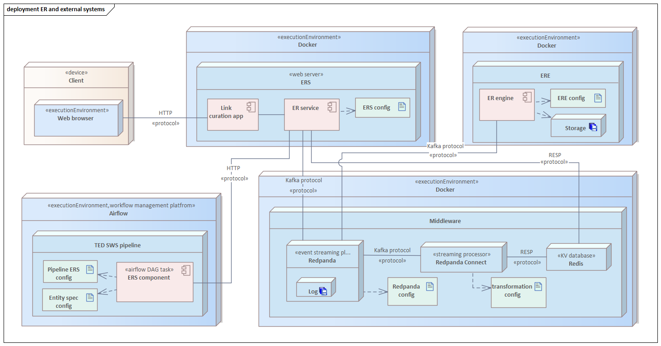

Experiments

Experimentation phase
A Jupyter/Marimo notebook demonstrating the operation and performance of the algorithms used by the inference engine will be prepared. Different options for the factors will be examined, and the best setup will be determined based on the Reduction ratio score. In addition to measuring the KPI, a basic statistical analysis (e.g., distribution of similarity scores) will be conducted to understand the characteristics of the generated alignments and any potential implications. The notebook will use a small sample of Notice RDF files from the output of the current version of the TED SWS pipeline.

Scope of experiments
For each of the topics below, a few options need to be tested before a final decision is made on what will be delivered (as described in the ERE):
- Embeddings model and its parameters
- Model toolkit (FAISS, Pinecone, LanceDB, Zilliz, SemHash, etc.)
- Clustering algorithms
- Similarity metric we will use (e.g. Cosine, Euclidean, etc. )
- Confidence threshold value
- Experiments with vector indexing (if necessary)

Key Performance Indicators
The following two measures will be implemented and tracked in order to determine the best ER setup:
- Reduction ratio (RR): it is a metric used to evaluate the effectiveness of entity resolution techniques that aim to reduce the number of entities considered distinct.
- Execution time
In the context of the offer, the reduction ratio is defined as follows:
Reduction Ratio = 1 - number of unique entities after resolving / total number of entities
The ratio is to be calculated for entities of the same type (CET).
As a baseline for comparison, a simple method based on the exact match of legal names (epo:hasLegalName property) is used. The baseline has been calculated on organizations (org:Organization) data. The baseline RR is equal to 0.869 (86,9%).
The reduction ratio calculated on data resolved by the implemented algorithm will be compared against the baseline and it must be higher than the latter.

TED pipeline for ERS
This document describes the existing pipeline version and doesn’t belong to the system proposal.
The document provides a summary of the TED SWS pipeline documentation in the context of the planned new component integrating the planned ERS system. The complete documentation can be found in the GitHub repository.

The workflow
The TED SWS processing system offers several workflows that all delegate work to the notice_processing_pipeline:
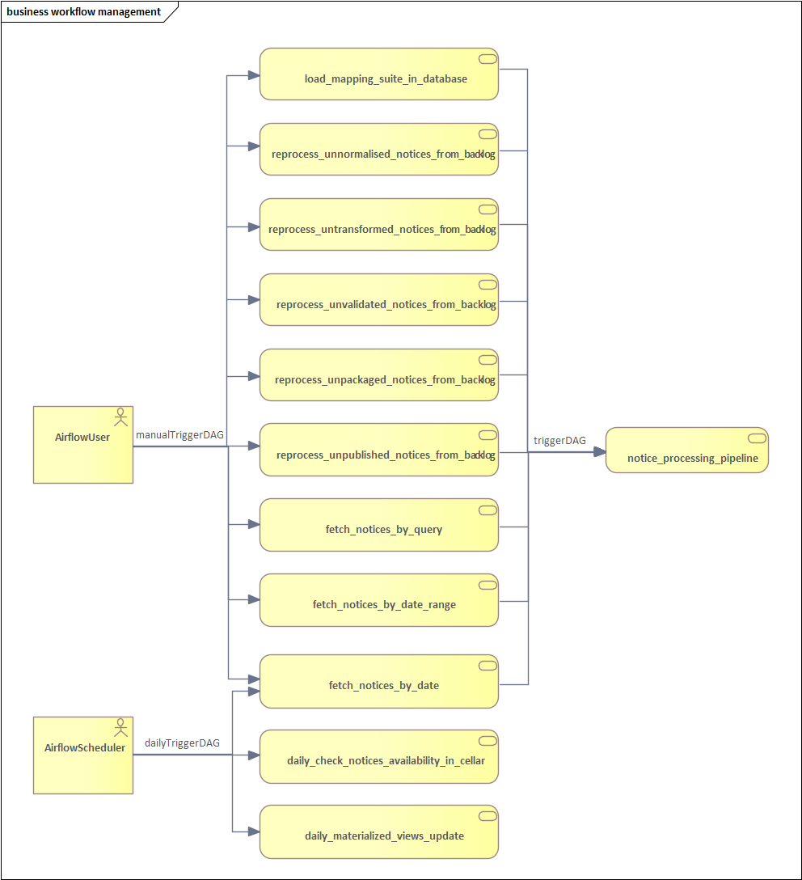
The TED pipeline transforms XML notice data into RDF. It consists of a set of transformation steps as presented below, each of which is handled by a dedicated component (service).
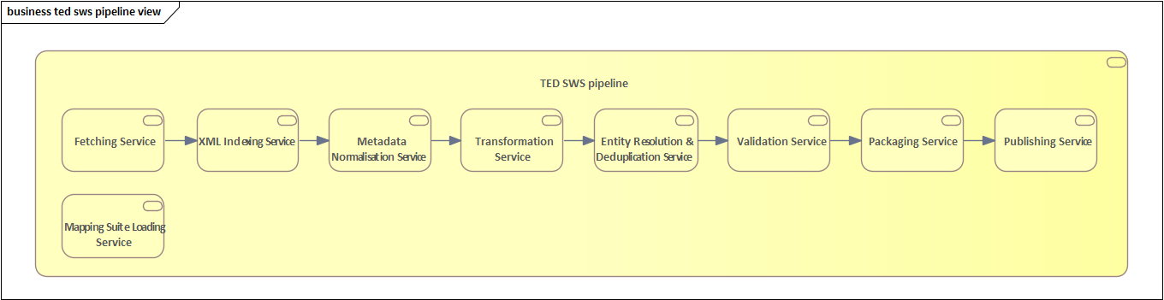

The Transformation Service is the service that transforms a notice from the XML format into the RDF format, using for this a Mapping Suite that contains the RML transformation rules that will be applied.

The technical realisation of the notice_processing_pipeline pipeline is presented below (Airflow DAG view):

Entity resolution and deduplication service
A component of a particular interest in the context of the entity resolution task is the Entity resolution and deduplication service. This service performs deduplication of entities from RDF manifestation, namely Organization and Procedure entities.

Input and output
The service receives identifiers of notices to process and stores a distilled RDF manifestation that is based on an RDF manifestation of a notice fetched from the shared database based on the identifiers.
New RDF statements linking entities of Canonical Entity Types using owl:sameAs property, incorporated into the returned RDF manifestation, is the direct outcome of the service execution:
Example:
epd:notice_org_id1 a epo:Organisation .
epd:notice_org_id1 owl:sameAs ers:entity_canonical_URI_id1 .

Notice representation

Statuses
The below diagram presents a notice status transition that is changed as the pipeline execution advances. The statuses correspond to and are set by different pipeline components.

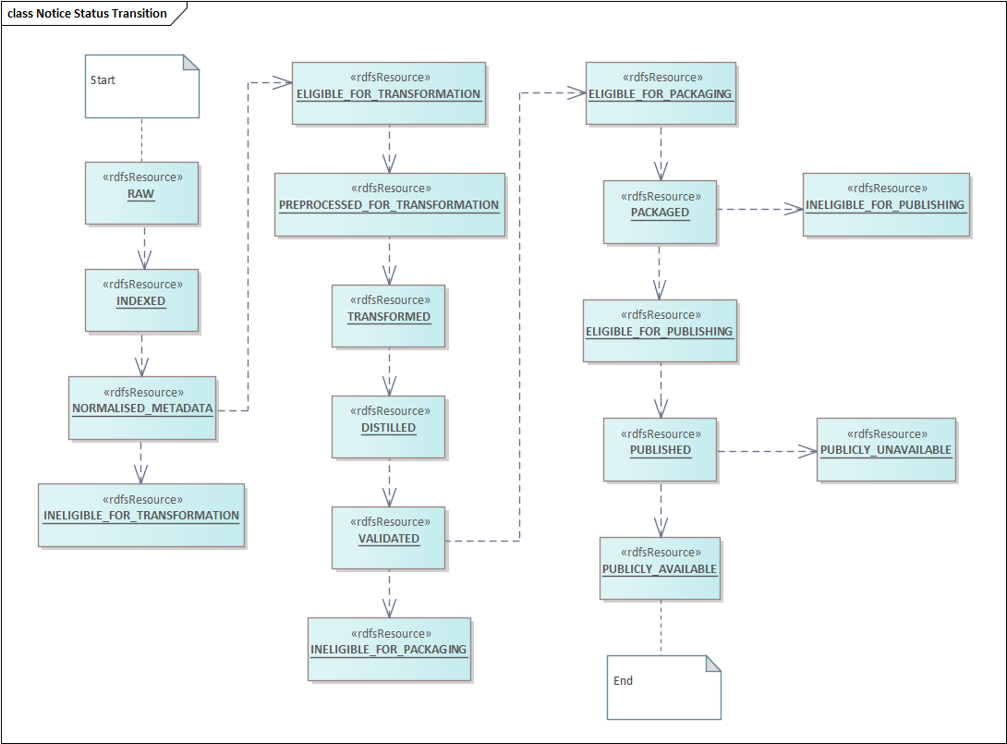

Two interesting statuses are TRANSFORMED and DISTILLED.
The TRANSFORMED status refers to an RDF manifestation of a notice.
The DISTILLED status is used to indicate that the RDF manifestation of a notice has been post processed. The post-processing of an RDF manifestation provides for the deduplication of the Procedure or Organization type entities and the insertion of corresponding triplets within this RDF manifestation.

The notice model
The Notice class in the notice.py module describes a data model that is used by the pipeline services. The class exposes a rich API, including getters and setters for both RDF manifestation and distilled RDF manifestation of a notice.

Infrastructure

Infrastructure
The AWS infrastructure diagram presents the organization of the ER system built on Amazon Web Services. It presents execution environments (containers run within AWS ECS), storage (AWS EFS), networking (VPC, Route 53 for DNS resolution) and other services.

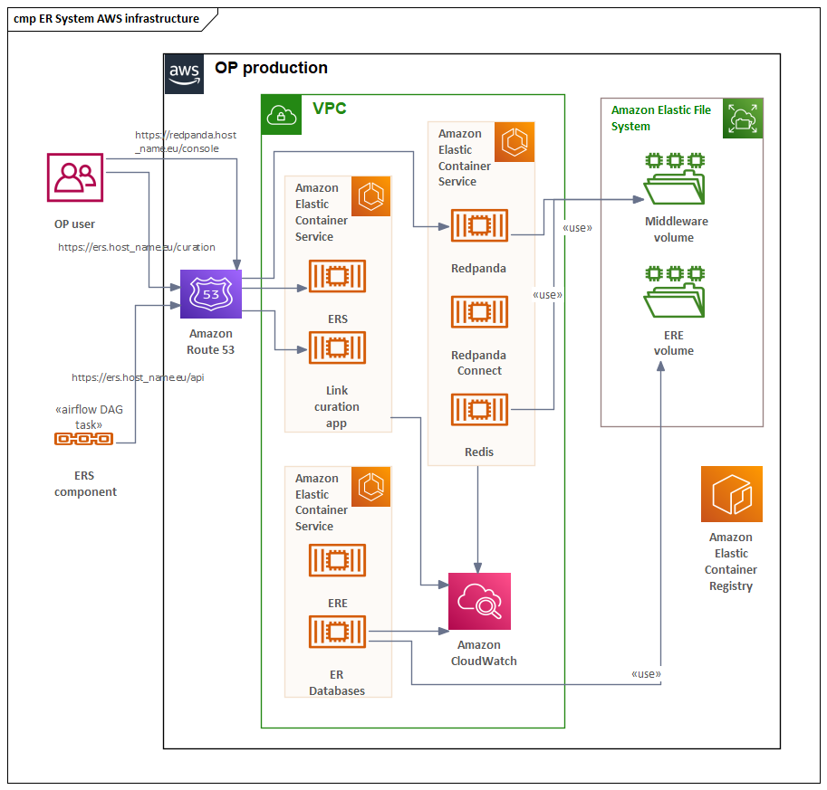

The diagram captures the ER system components (ERS, ERE and the middleware) at the container level (see the deployment diagram for more details). Containers are built from images stored in Elastic Container Registry and run in Elastic Container Services. The services operate within a single shared Virtual Private Cloud. CloudWatch is leveraged for monitoring resources. Redpanda requires storage for log data and Redis for persisting log indexes. The two use an Elastic File System volume dedicated to the middleware. ER engine requires one or more operational databases. These are persisted in a dedicated volume. The system can be used in two ways, by two kinds of users: human and machine. The former uses a web application for link curation. The latter accesses the REST API of the ER service. In addition, a user has access to the Redpanda Console, a web interface to the Redpanda streaming platform, that is used for monitoring and administering purposes. All three are accessed via domain names that are resolved and linked to internal service addresses with Amazon Route 53.

⚠️ Simplification ideas

Introduction
This document contains 2 attempts to simplify the original architecture. The attempts have been generated by Chat GPT, hence reading it may be daunting in places, whereas in other some good ideas are proposed. At the end, there is also a comparison of the two simplification attempts.

I highlight places where I see some good ideas.

Simplification ideas
- The Application based on Streamlit
  - Instead of Angular with eUI and EU Login
- The ERE is reused based on what currently exists in the TED-SWS
  - Instead of creating a new LLM based engine and
  - Thus no need for the experimentation phase
- Two component architecture
  - ER Service + ER Engine bound via async message-queue notification systems (Redis)
  - Instead of event stream platform, and
  - Thus no need for the middleware scaffolding
- System of Records based on a DB (MongoDB)
  - Instead of event stream platform
- Resolved Data repository based on a DB (MongoDB)
  - Instead of event stream platform
- Drop cluster evolution lineage/metadata/log
  - Only the latest cluster state is available (clusters evolve but no history is traced) + the system emits change notifications
  - Instead of full history of cluster evolution

Simplification attempt 1

Architectural simplifications that save time
The biggest complexity and cost centre lies in:
- The middleware: Redpanda + Redis log index + event contract
- The clustering + vector infrastructure (e.g. Milvus, HDBSCAN)
- The link curation frontend
- The modular ER engine contract (flexible but abstract)

Area | Change
Middleware | Replace Redpanda + Redis with a lightweight internal queue (e.g. Celery with Redis or even PostgreSQL job queue)
ERE Plug-in Framework | Postpone the plug-in contract with AsyncAPI. For now, treat ERE as a fixed component behind a REST API
Log-indexed lookup layer | Replace with canonical + unresolved entity tables in PostgreSQL or document store
Lineage metadata | Defer full lineage tracking and canonical URI evolution logic
Custom UI for Link Curation | Use a low-code UI framework (e.g. Retool, Streamlit) to build the first version
Model experimentation | Leverage LIMES engine for MVP and defer embedding-based or LLM-based exploration
Config split | Collapse all YAML configuration into a single file per environment

Full vs Trimmed ERS System Architecture
Component / Capability | Full Architecture | Trimmed Architecture | Rationale / Impact
Middleware (Event Streaming) | Redpanda + Redis + Stream processor | In-memory queue or Celery with DB | Cuts infra complexity; OK for low load & 1 ERE
Communication between ERS and ERE | Kafka-like async, via middleware | Direct REST call (sync or async) | For MVP, REST avoids event infra setup
Log-based immutable store | Redpanda logs + offset-based access + Redis index | PostgreSQL table for input/output entities | Simpler lookup + persistent storage; replay not critical yet
Canonical URI versioning & lineage | Full version tracking (replaces, invalidates) | Static canonical URI per entity | Simpler to manage; can defer re-clustering impact
Link Curation Interface | Custom UI + API + manual feedback logs | No-code/low-code UI (Retool, Streamlit) | Same value, less effort; backend stays
ERE plug-in interface | AsyncAPI contract, engine-agnostic channel mapping | Single ER engine behind internal API | Pluggability abstracted for now; revisit once multiple EREs needed
ER Engine | Embeddings + HDBSCAN + Milvus/FAISS + lineage | LIMES (reuse) or minimal cosine sim + dict store | Leverage existing RDF tech already in TED
Entity Extraction | CBD/GCBD/DPD extraction strategies + enrichment config | Retain as-is (lightweight config) | Essential for TED pipeline — no change
Data model awareness (ePO, CETs) | Future extension; supports domain-aware logic | Single CET (org:Organization) in RDF | Simplifies dev/test/data curation
Authentication | EU Login integration | Same (EU Login only) | Required regardless
User feedback handling | Stored in stream + plans for retraining | Stored via REST API, no retraining | Functional parity without added ML logic
Multiple entity formats | RDF, JSON, XML, plain text | RDF only | Covers TED use case; extend later
Configuration management | Multiple YAML files, per component | Single YAML per env (ERS + ERE combined) | Simpler onboarding, fewer bugs
Streaming Processor & Log Index | Redpanda Connect + Redis | Drop (use SQL queries or indexed view) | Significant simplification
Deployment footprint | 5–6 services (ERS, ERE, middleware, Redis, Redpanda, UI)

Possible roadmap
Phase | Task
1. Project Setup | Kick-off, team onboarding, environments, planning
1. Project Setup | Technical architecture + decision log
2. ERS Core | Implement ERS service (REST API)
2. ERS Core | Implement PostgreSQL storage (canonical, unresolved)
2. ERS Core | Develop simple queue for async requests
3. ERE Integration | Wrap LIMES as a resolution engine
3. ERE Integration | Create REST-based adapter for ERE
3. ERE Integration | Canonical entity assignment logic
4. Link Curation | Implement REST endpoints for alignment feedback
4. Link Curation | Build lightweight UI (Streamlit/Retool)
5. TED Integration | Entity extraction logic (RDF, GCBD)
5. TED Integration | ERS component in pipeline + enrichment
6. Validation & Docs | Testing (unit + integration + E2E)
6. Validation & Docs | Documentation (config, usage, API, UI)
6. Validation & Docs | Buffer for bug fixing and polish

Simplification 2

Full vs Trimmed ERS Systems
(Variant A = “Lean but future‑proof”, Variant B = “Ultra‑MVP”)
Facet / Component | Baseline in Original Proposal | Variant A – Lean but Future‑Proof | Impact & Rationale
Event‑driven middleware | Redpanda + Redis index + Redpanda Connect (immutable logs) ERS system proposal v3 … | Replace with RabbitMQ (durable queues) or PostgreSQL LISTEN/NOTIFY. ‑ Keeps async & loose coupling; add a thin “Replay Service” that can copy messages if true replay ever needed. | A meets durability & decoupling without Kafka‑class ops. B cuts ~100 MD but sacrifices replayability; acceptable if volume is modest.
Log‑indexed lookup (Redis) | Separate Redis key–value index for fast entity look‑ups ERS system proposal v3 … | Use composite indexes in PostgreSQL (requestId, originId, canonicalUri). | A preserves O(1)/O(log n) look‑ups with minimal infra. B is simplest but may slow under heavy load.
Lineage / versioning | Full replaces / invalidates graph, stored in metadata and index ERS system proposal v3 … | Store a predecessor_uri column; support only merge events for now. | A gives single‑step history with 1 extra join; B removes ~15 MD of logic & UI but drops auditability.
ERS‑ERE contract & transport | AsyncAPI over Kafka topics (language‑agnostic) ERS system proposal v3 … | REST+JSON contract (OpenAPI) with one endpoint /resolveBatch. Provide a stub adapter to upgrade to queues later. | Variant A keeps pluggability; Variant B removes inter‑service latency & infra but the engine is no longer hot‑swappable at runtime.
Entity Resolution Engine | New embedding‑based engine (HDBSCAN + Milvus) ERS system proposal v3 … | Start with LIMES (already in TED‑SWS) as primary engine; add tiny wrapper so it conforms to REST interface. | Saves 25‑40 MD of model work; still meets requirement of pluggable engine ERS system proposal v3.
LLM “bonus” | Planned for future | Optional micro‑service: pass low‑confidence pairs to GPT‑4 for human‑readable justification; feature‑flagged. | Keeps client excited without blocking schedule; ~5 MD.
Link‑curation UI | Custom React + API + pagination ERS system proposal v3 … | Retool/Streamlit MVP + simple backend endpoints. | A delivers web UX in <15 MD. B slashes to near‑zero but loses instant visualisation.
Configuration strategy | Multiple YAML files per service ERS system proposal v3 … | Single ers.yml merged at start‑up; subsection per component. | A simplifies DevOps while staying flexible. B good for PoC images.
Infrastructure (AWS ECS, Route 53, EFS) | Full production‑grade stack ERS system proposal v3 … | Docker‑compose for dev; single ECS task in prod; EBS volume instead of EFS. | Variant A retains cloud best‑practices; Variant B chops provisioning time but sacrifices HA.
Testing pyramid | Unit + FAT + E2E (Cucumber) ERS system proposal v3 … | Unit + minimal integration suite via Pytest‑httpx; smoke E2E in GitHub Actions. | A gives reasonable coverage (~15 MD). B fastest but risky.
Documentation | Swagger + AsyncAPI + developer guides ERS system proposal v3 … | Swagger only; inline code comments; 3‑page quick‑start. | A still satisfies transparency ERS system proposal v3; B bare minimum.
Security / Auth | EU Login + no RBAC ERS system proposal v3 … | Keep EU Login; add API key option for non‑interactive pipeline. | Variant A minimal extra work; Variant B not client‑acceptable for prod.

Comparison of Option 1 and Option 2

1. Middleware & Messaging
Criterion | Option 1<br>“Celery / PostgreSQL queue” ERS system proposal v3 … | Option 2<br>“RabbitMQ or PostgreSQL LISTEN/NOTIFY”
Viability | High—Celery is battle-tested in Python stacks. | High—RabbitMQ is mature; LISTEN/NOTIFY is built-in to PG.
Robustness | Medium—Celery tasks can be lost if worker crashes; PG queue less durable. | High—RabbitMQ durability out-of-the-box; PG pub/sub durable but no message persistence by default.
Complexity | Low—only Python + DB deps. | Medium—requires RabbitMQ ops or careful PG configuration.
Future-proofing | Low—harder to evolve into true event log or replay. | Medium—RabbitMQ may scale to topic-based patterns; PG pub/sub can evolve into log via extension.
Requirement Fit | Meets: Asynchronous decoupling; violates replayability. | Meets: Async & decoupling; partially meets durability; replay requires add-on.

2. Log-Indexed Lookup Layer
Criterion | Option 1<br>“PostgreSQL tables” ERS system proposal v3 … | Option 2<br>“Composite indexes in PG”
Viability | High—straightforward CRUD. | High—indexes are trivial to add.
Robustness | Medium—single point of failure; no separate cache layer. | Medium—good for moderate scale; heavy queries can slow down DB.
Complexity | Low—no extra services. | Very Low—just schema changes.
Future-proofing | Low—harder to migrate to a dedicated index store later. | Medium—PG can be swapped for a document store, but code changes needed.
Requirement Fit | Meets lookup & persistence; violates high-throughput guarantee. | Same.

3. Lineage & Versioning
Criterion | Option 1<br>“Defer all lineage” ERS system proposal v3 … | Option 2<br>“Single predecessor_uri column”
Viability | High—no additional tables or logic. | High—small schema change.
Robustness | Low—cannot audit or track cluster evolution. | Medium—captures one-step history, but not multi-step.
Complexity | Very Low. | Low.
Future-proofing | Very Low—no path to richer lineage without rework. | Medium—can be extended to a full graph later.
Requirement Fit | Violates auditability requirement (N4). | Partially meets minimal provenance (N4.2) but not full lineage (N4.3).

4. ERS–ERE Integration
Criterion | Option 1<br>“REST-only adapter” ERS system proposal v3 … | Option 2<br>“Co-locate ERE as library”
Viability | High—simple HTTP calls. | High—zero network overhead.
Robustness | Medium—network failures can interrupt resolution. | Low—requires in-process stability; crash of one module down entire service.
Complexity | Low. | Low-Medium—merges two codebases.
Future-proofing | Medium—still pluggable via REST, can evolve to queue. | Low—hard to swap out engine at runtime.
Requirement Fit | Meets pluggability (if multiple EREs needed later); violates strict independence if REST is blocking. | Violates ERE independence (N “System independence”); violates pluggability (cannot hot-swap engine).

5. Entity Resolution Engine
Criterion | Option 1<br>“LIMES wrapper” ERS system proposal v3 … | Option 2<br>“LIMES + fallback rules”
Viability | High—LIMES is already in TED-SWS. | High—fallback rules are trivial to author.
Robustness | Medium—rule-based only handles tidy data. | High—rules catch typos, improving recall.
Complexity | Low. | Low-Medium—extra rule maintenance.
Future-proofing | Medium—can later swap to vector engine. | High—wraps both rule and future vector engines behind same interface.
Requirement Fit | Meets “always return URI” requirement; violates ML/LLM experiment goal. | Meets both deterministic and fuzzy matching, aligns with client’s LLM interest if rules augmented later.

6. Link-Curation UI
Criterion | Option 1<br>“Streamlit/Retool” ERS system proposal v3 … | Option 2<br>“CSV+Excel offline”
Viability | High—quick to spin up. | Very High—no dev needed.
Robustness | Medium—depends on third-party service availability. | Low—manual process; prone to errors.
Complexity | Low. | Very Low.
Future-proofing | Medium—can build custom UI later. | Very Low—hard to migrate to web UI.
Requirement Fit | Meets manual curation requirement (N6). | Violates UX expectation; no real-time feedback.

7. Configuration Management
Criterion | Option 1<br>“Single YAML” ERS system proposal v3 … | Option 2<br>“Env-vars only”
Viability | High. | High.
Robustness | Medium—YAML parsing, single point of failure. | Medium—env-var drift possible.
Complexity | Low. | Very Low.
Future-proofing | Medium—easy to add new sections. | Low—hard to document complex configs.
Requirement Fit | Meets configurability (N7). | Violates easy stakeholder edits.

Clustering Ideas for pairwise similarity between URIs
Representing hundreds of millions of URIs as a full n×n distance matrix simply won’t fly—at n = 10⁸ you’d need 10¹⁶ entries, even a sparse float16 array would exhaust petabytes of RAM. In practice you should never build the complete matrix. Instead:
- Sparse edge list (neighbor graph)
  - Threshold your similarities (e.g. only keep edges where sim > 0.8) so you store only a few neighbors per node.
  - Represent that as a SciPy sparse matrix or as an edge list on disk/NoSQL store.
- On-the-fly neighbor queries
  - Use an approximate nearest-neighbour index (FAISS, Annoy, NMSLIB) to retrieve each point’s k closest neighbours when you run DBSCAN.
  - This avoids any O(n²) precomputation and keeps your memory footprint to O(n·k).
As for implementations beyond scikit-learn:
- HDBSCAN (pip install hdbscan)
  - C-optimized, handles precomputed sparse graphs, and often yields more stable clusters without precise eps tuning.
- cuML’s DBSCAN (part of RAPIDS)
  - Runs on GPUs, blazing-fast for millions of points, but you still need to feed it neighbor lists rather than a full matrix.
- Dask-ML DBSCAN
  - Offers an out-of-core, chunked approach on large clusters, integrating with Dask Arrays and sparse structures.
- Spark MLlib (community packages)
  - If you already have a Spark cluster, third-party DBSCAN implementations can process huge datasets in a distributed fashion.
Bottom line: don’t attempt a full matrix for 10⁸ entities. Build a sparse neighbor graph—using approximate k-NN if necessary—and then choose an implementation like HDBSCAN, cuML or Dask-ML that can consume that sparse structure efficiently, rather than scikit-learn’s in-memory matrix approach.

Notes on cluster repositories
When you look at the role of a cluster manager—whether it’s spinning up Dask, Celery or Spark workers—you’ll see it’s really an execution concern rather than a coordination concern. In other words, the Entity Resolution Service (ERS) is responsible for accepting requests, maintaining the immutable input log and the canonical-entity registry, and orchestrating the overall workflow (e.g. “take record X, resolve it, store the match”). By contrast, the Entity Resolution Engine (ERE) is where the heavy lifting happens: it needs to decide how to scale out its matching algorithms over a compute cluster, monitor job progress and collect results. Placing the cluster manager inside the ERE implementation keeps all of that scaling logic, resource management and retry policies encapsulated within the engine itself, leaving the ERS free of infrastructure details.
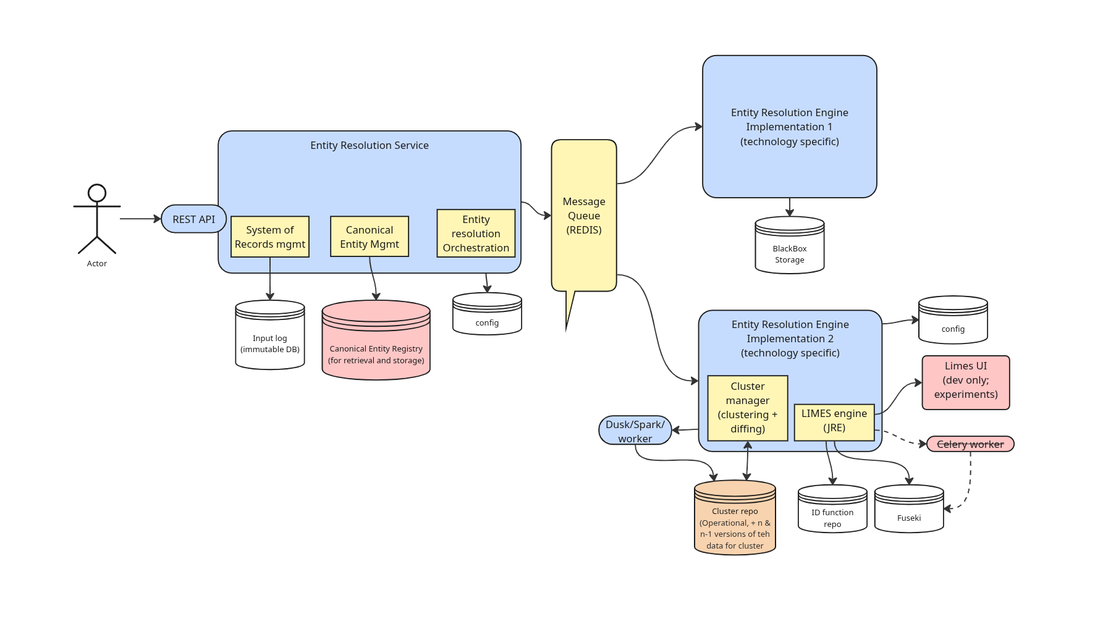
Likewise, your cluster repo—the data store where intermediate clustering results (entity-to-cluster mappings, cluster centroids or lineage information) live—is conceptually different from the canonical entity registry, which records final, curated input→output pairs. The registry is your single source of truth for “this input resolves to that canonical ID,” whereas the cluster repo captures the working state of a whole graph of similarity groups before they’re collapsed into canonical entries. By keeping these two stores separate you preserve a clear audit trail: you can trace back from any canonical ID to the precise cluster composition and algorithm run that generated it, without muddying your production registry with transient or experimental cluster data.

Towards a Benchmark for LOD-Enhanced Knowledge Discovery from Structured Data

